Minutes of Meeting
Meeting Title | PPG Meeting
Date of Meeting | February 6th, 2025 | Time | 10.30 | Chair | Emma Grace
Venue/address | The Maples Health Centre |  |  | Minute Taker | Jenni Fox

Attendees
Emma Grace | Jenni Fox | B. W | S. W
P. C | M. C | J. S | L. S
L. S | V. E-S

Item No. |  | Agenda Items | Who | When
Apologies:
Dr. M
2.  3.  4.  5.  6. | Building Works  The building works are due to start Week commencing Feb 24t^{h}. They should be staring with the boiler. Then work will start Phase 1 – top floor expected to last approx. 7 weeks.  We will then open a temporary reception desk in the upstairs waiting room and work will commence downstairs.  Plans were shown to the Group  Capacity and Demand  Demand has been huge since Christmas. Even with the extra winter pressure funding we cannot keep up with the demand. On our SHREWD reporting to ICB 80% of the time we are indicating as Red.  Have had a lot of patients from Warden Lodge and Park Lane surgeries, who don’t like online triage format, register with us.  We have created a new web page which we will try to use this to explain the issues facing GP Practice.  https://themapleshealthcentre.co.uk/news/why-cant-i-get-an-appointment/  The Maples have just under 3,000 patients allocated per Doctor.  We are using Pharmacy First Scheme more and ones that are unable to go through the pathway are put with the duty clinicians. Currently we are also trying to educate more about difference between Urgent Care Centres and A/E departments.  V.E-S. mentioned the confusion surrounding the Cheshunt Minor Injuries Unit and what can and can’t be treated there.  We triage and signpost there where needed also but they have changed some of their criteria.  Lewis Cocking Visit  We had a visit from MP Lewis Cocking on December 2nd. The visit went well. P.C. was able to attend and V.E-S emailed her concerns which we passed on.  We showed him our data presentation and discussed growing concerns to general practice staffing, finance and general patient feeling. Emma showed October Demand / Data to the group  Lewis is very against total online triage.  We discussed that like all previous MPs he will get complaints about GP Practices, but hopefully, he will have a better insight into all of the various challenges we face. We also encouraged him to recommend that patients join their PPG in their Practice to be able to share Their views and learn about the surgeries services.  He has invited us to the Older Person’s Fair on Friday April 4th at Halsey Hall.  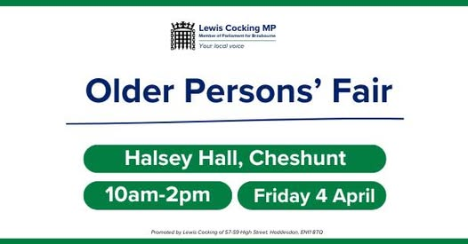  Memory Hub / Carers Information Cafe  Dementia hub has been rebranded as Memory Hub. They are a multi-disciplinary service run by both PCN teams in the area. The team can do reviews, diagnose and put people in touch with relevant charities and services who are also in attendance. The clinic is run the last Friday of every month at the Laura Trott Centre. Free Parking is offered to attendees.  There is also a free drop in for Carers at the Carers Information Café, the Second Wednesday of every month at Laura Trott also. Daniel (Carer’s Lead) and Emma are popping along to the February meet up.  AOB  V.E-S asked about Social Prescribers. Emma explained their role is to provide the link to community and social services. They will do welfare checks, visit patients, put people in touch with other services that can help with various challenges.  V.E-S asked how everyone was coping. Emma explained we have an amazing Practice Manager in Claire. Jenni concurred 100%.  Times are incredibly tough, but we love our team and support each department each getting stuck in when needed. |  | EG to attach link  EG to attach flyers etc
 | Date of Next Meeting: TBC

